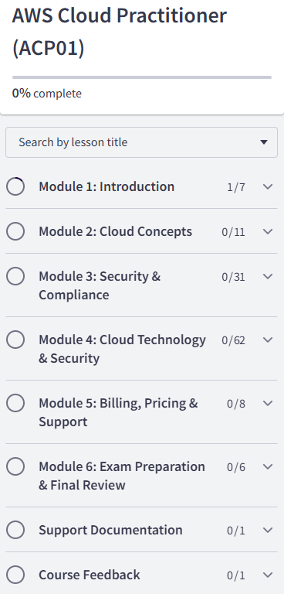

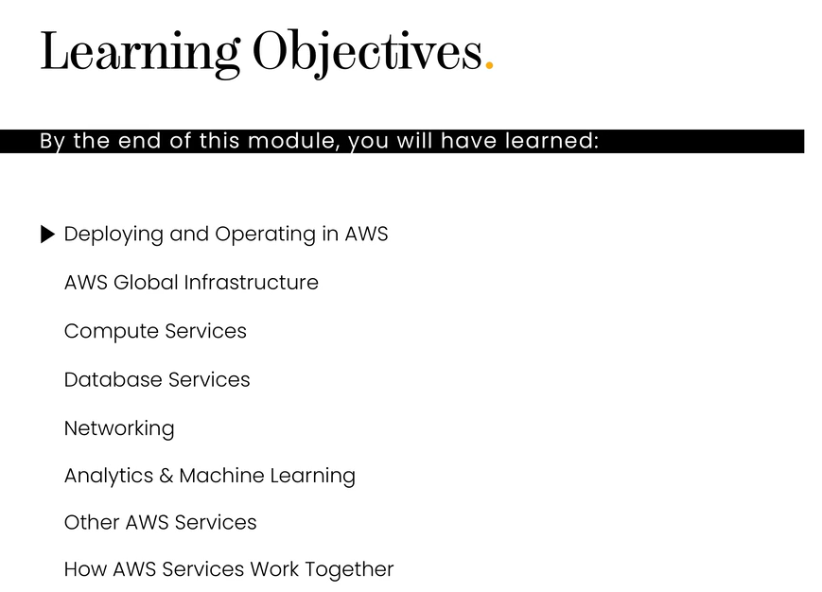

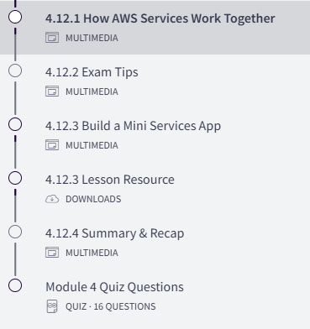

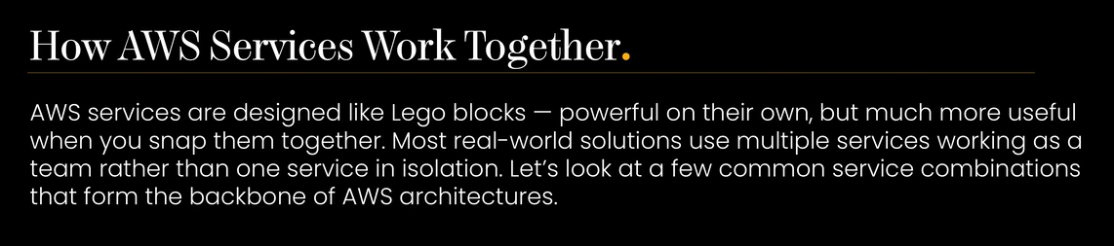

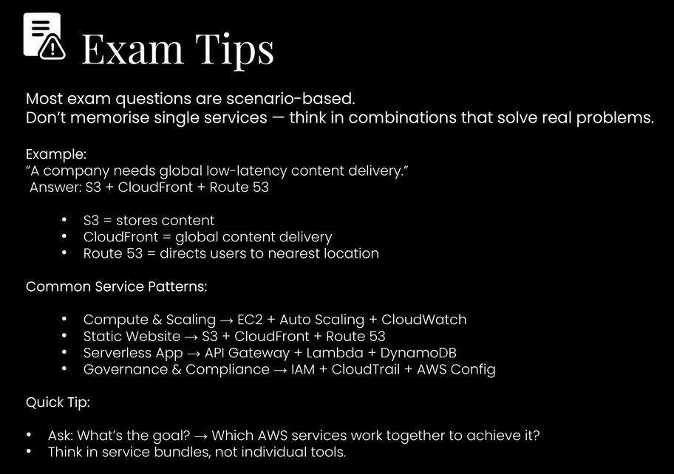



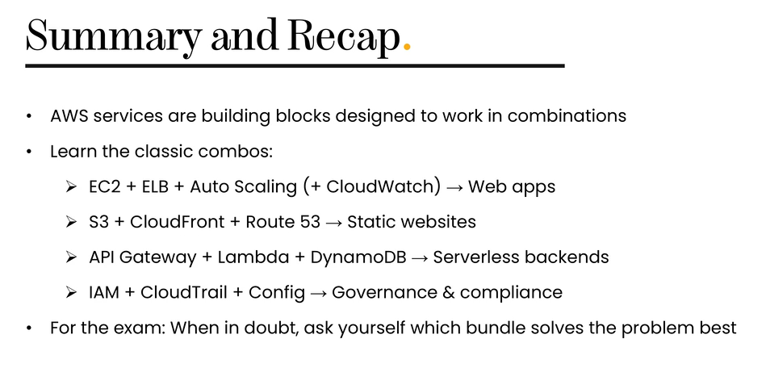

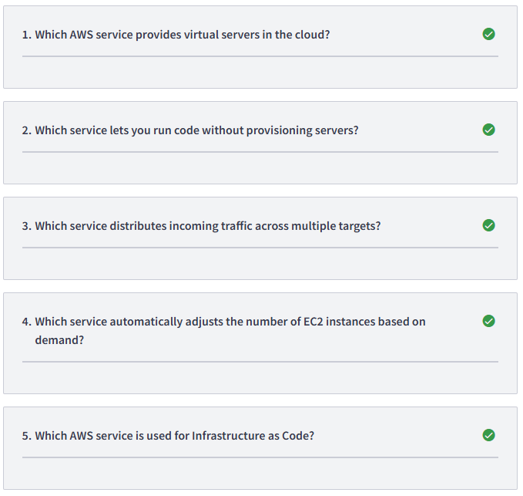

1/ Amazon EC2
2/ AWS Lambda
3/ Elastic Load Balancing
4/ Auto Scaling
5/ CloudFormation
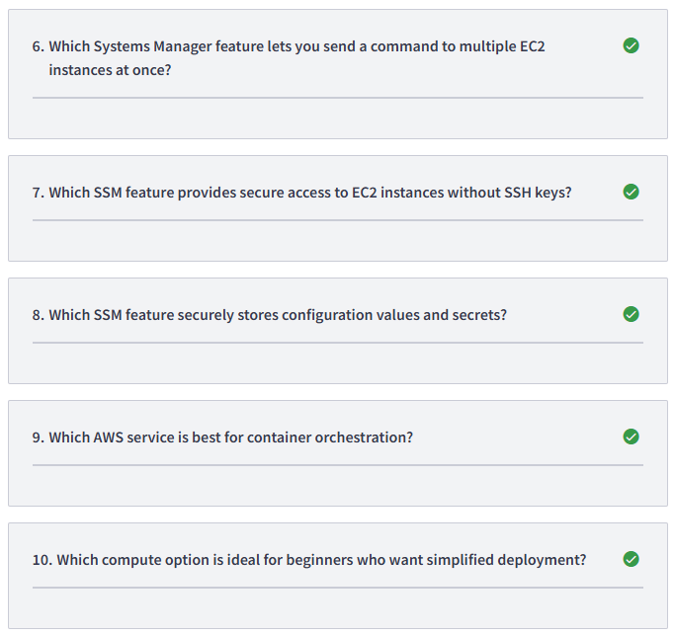

6/ Run Command
7/ Session Manager
8/ Parameter Store
9/ Amazon ECS
10/ Elastic Beanstalk
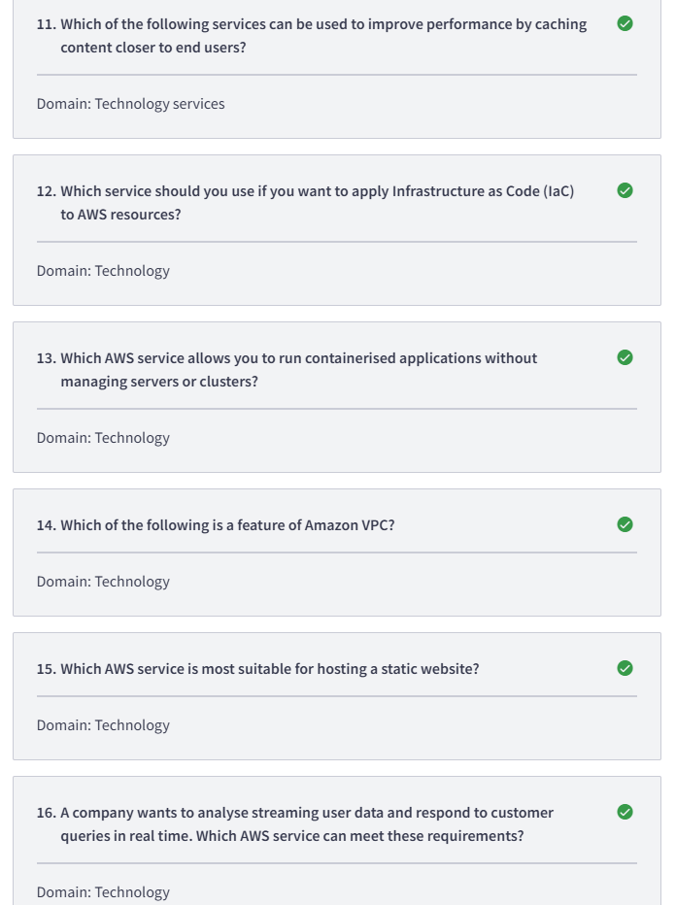
11/ Amazon CloudFront
12/ AWS CloudFormation
13/ Amazon ECS with Fargate
14/ Isolation of network environments
15/ Amazon S3
16/ Amazon Kinesis Data Analytics

